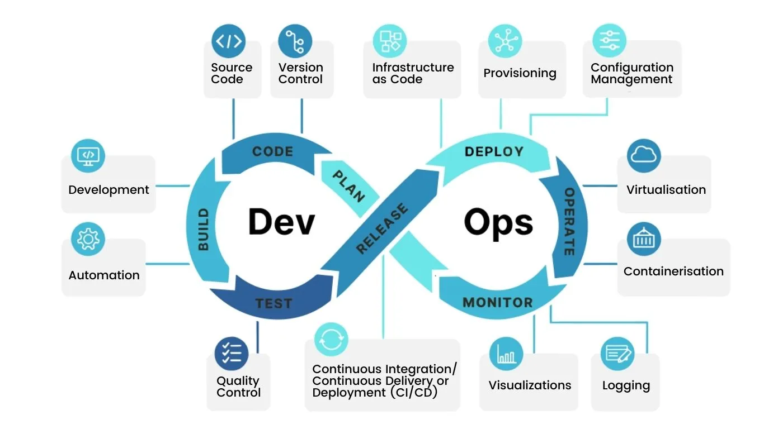

1. **Planning:** It’s the initial stage of the development and operation process, where teams figure out what they want to build, what features are needed, and how everything should work.
2. **Code:** the phase where developers write the code for the application. DevOps emphasizes using version control systems (like Git) to keep track of changes and enable collaboration among developers.
3. **Build:** The code is built into a usable application once written. DevOps uses automation tools to compile the code, package it up, and prepare it for testing. This ensures consistency and speeds up the process.
4. **Test:** It’s crucial as it ensures the application is free from bugs., DevOps promotes continuous testing, which means running automated tests throughout the development process, rather than waiting until the end. This helps catch problems early on when they're easier to fix.
5. **Release:** It involves preparing the application for deployment to a production environment. DevOps focuses on automating the release process to make it more efficient and reliable.
6. **Deploy:** The application is deployed to the server or environment where it can be accessed by the user. DevOps aims to make deployments as smooth and painless as possible, often using automation to minimize downtime and reduce the risk of errors.
7. **Operate:** The application is monitored once it’s up and running in production to ensure it performs well and issues can be addressed quickly. DevOps emphasizes proactive monitoring and uses tools to track key metrics and alert teams to potential problems.
8. **Monitor:** This involves keeping a close eye on the application and the infrastructure to ensure everything is running smoothly. DevOps teams use various monitoring tools to track performance, identify issues, and gain insights into how the application is being used.

The key aspects of the DevOps Process are:

**Continuous Integration (CI):** Developers regularly merge their code changes into a central repository, and automated builds and tests are run to catch any errors early.

**Continuous Delivery (CD):** Code changes are automatically built, tested, and prepared for production release.

**Continuous Deployment:** Code changes that pass all the automated tests are automatically deployed to production.

**Automation:** Automating repetitive tasks throughout the DevOps process is essential for speed, efficiency, and reliability.

**Collaboration:** Close collaboration between development and operations teams is a hallmark of DevOps.

**Feedback:** Continuous feedback is gathered from all stages of the DevOps process to identify areas for improvement.

The DevOps process is a continuous cycle of development, testing, release, and operation, with a strong emphasis on automation, collaboration, and feedback. This enables organizations to deliver software faster, more reliably, and with greater agility.